**Employee Attrition Prediction Report**

*Name: Srashti Tiwari*

*Date: April 09, 2024*

**Aim**: This project aims to provide insights into the factors influencing employee attrition and predict which employees are likely to leave the company.

**Problem statement:** Acme Corporation, a leading tech company, is facing a significant challenge with employee turnover. The HR department is concerned about the increasing rate of attrition, as it negatively impacts team dynamics, project continuity, and overall company morale. To address this issue, Acme Corporation wants to leverage data analytics and machine learning to understand the factors influencing employee turnover and predict which employees are likely to leave in the near future.

**Dataset:** Acme Corporation has provided historical data on employee demographics, job satisfaction, work environment, performance metrics, and turnover status. This dataset spans the last five years and includes information on employees who have left the company and those who are still currently employed. Following is a sample row*-*



Analysis & Interpretation: The target value Attrition is a categorical variable with the values ‘Yes’ and ‘No.’ The dataset is highly imbalanced and contains significantly more examples for ‘No’ than ‘Yes’.

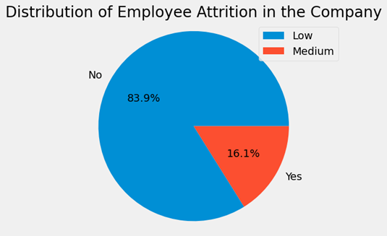

Data preprocessing was done. There are no missing/null values in the dataset. We observe that the features ‘EmployeeCount’, ‘Over18’, and ‘StandardHours’, ‘EmployeeNumber’, ‘StockOptionLevel’ add no value to attrition prediction.

Below is the PowerBI Dashboard-

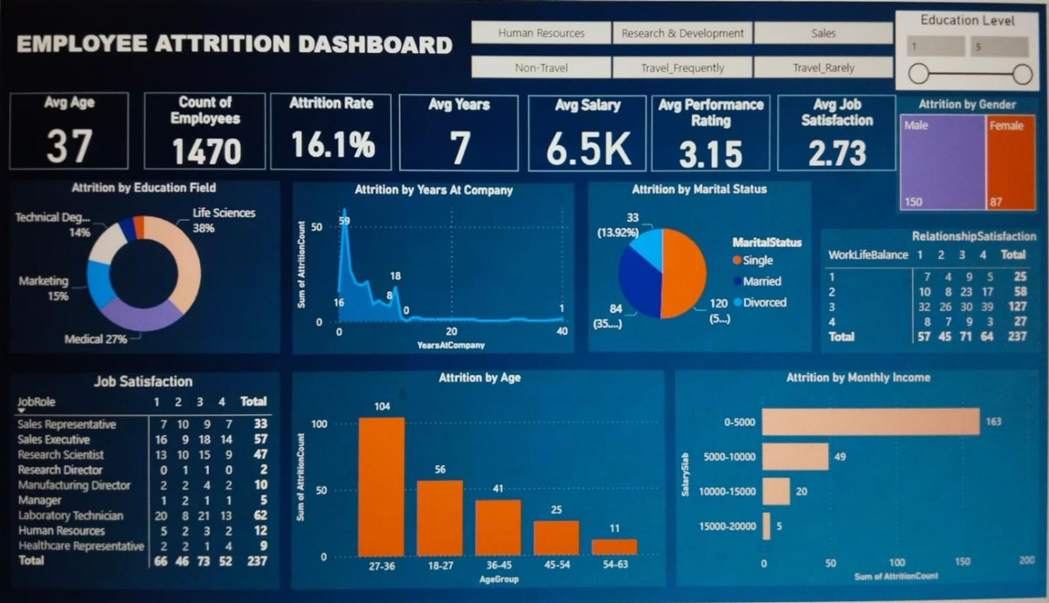

This dashboard gives us the various insights to understand several factors affecting the employee attrition.

The attrition rate is 16.1%.

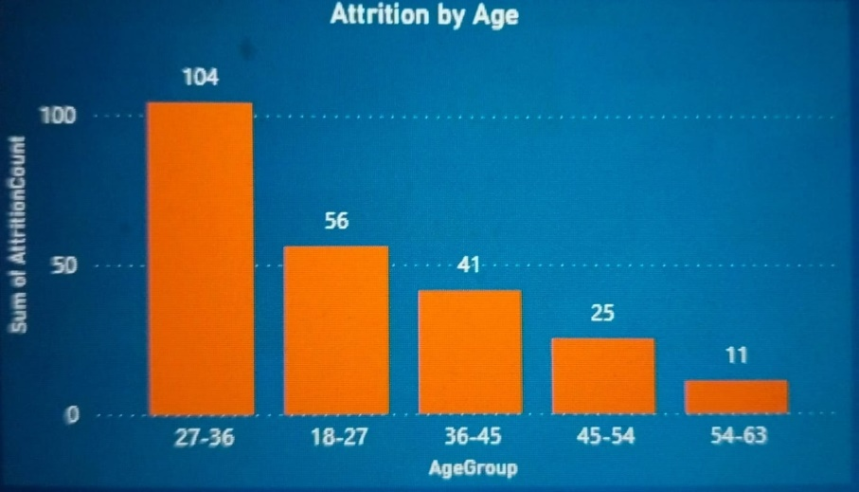It is observed that those employees whose age lying between 27 to 36 years are more likely to leave the job.

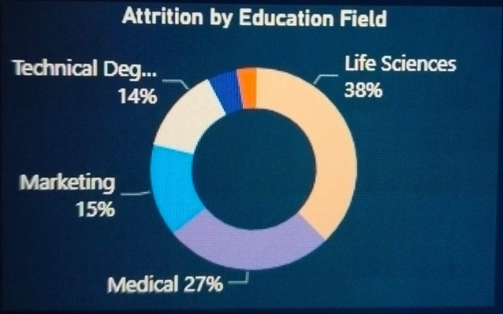

Employees who have educational background of life sciences are the most likely to leave the company by 38%.

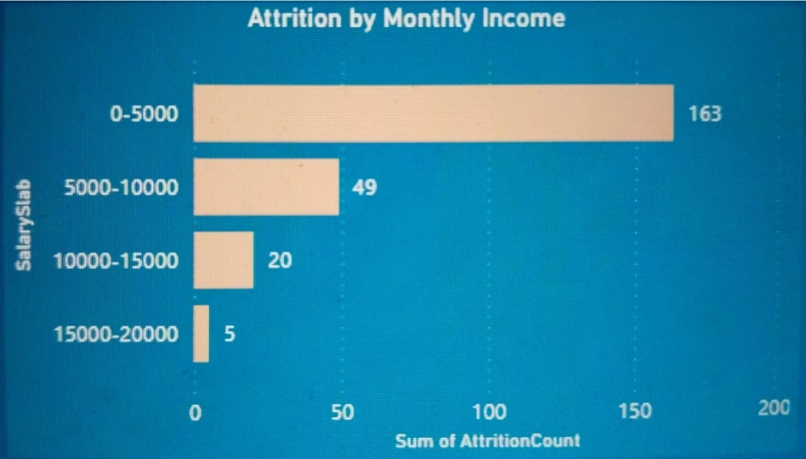

Employees having monthly income below 5k are generally leaving the company.

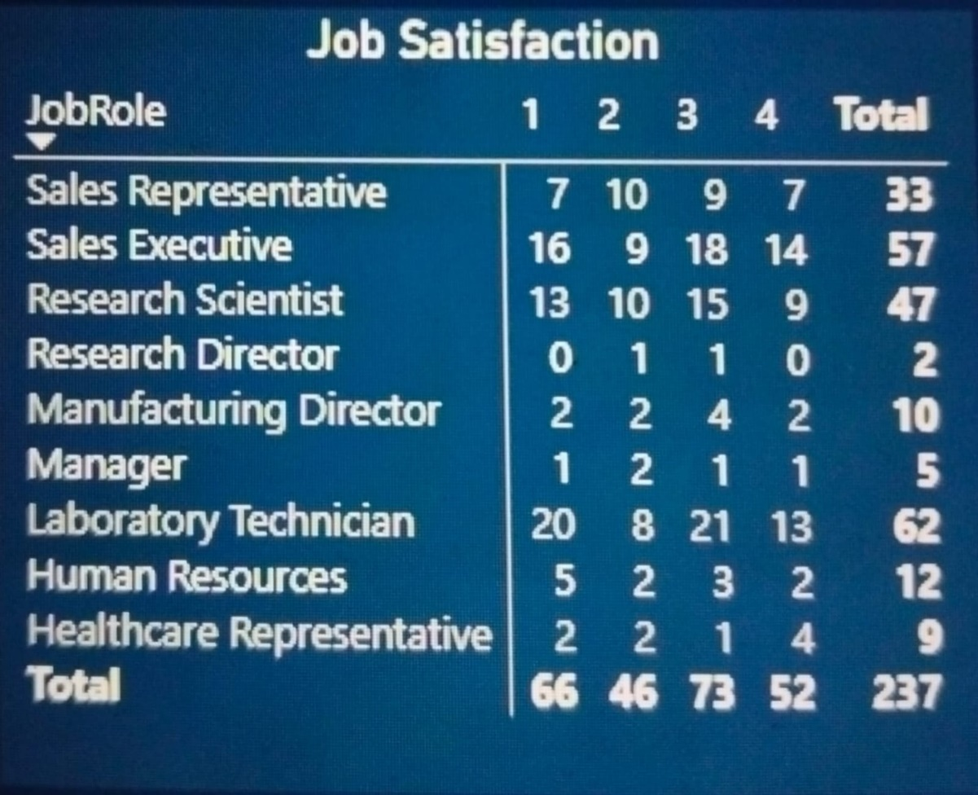

From the above table, it is clear that the lab technicians (62) are highest in number to leave the job followed by sales executives (57) and research scientist (47).

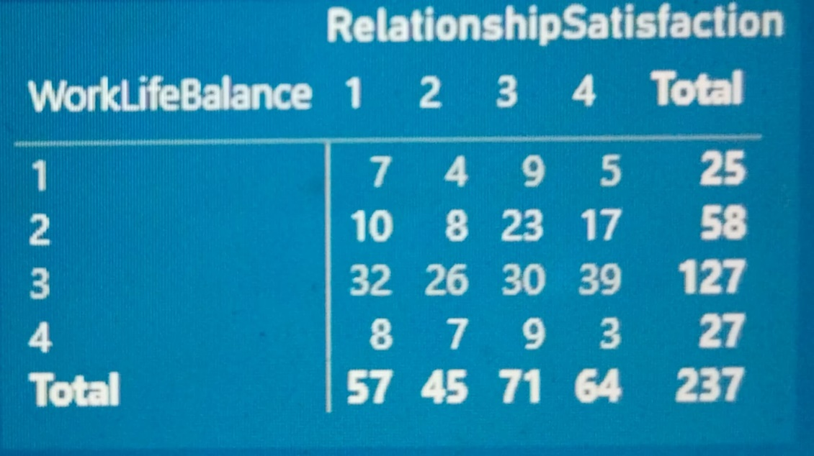

Here we can observe that the work life balance and the level of satisfaction with relationships at the workplace are not major factors in affecting the amount of attrition.

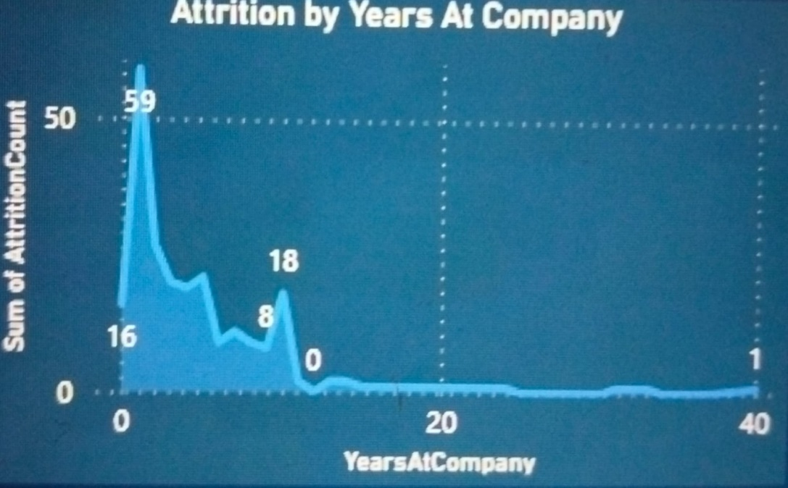

It is observed that the newly arriving employees quit their jobs most in the initial period within two years.